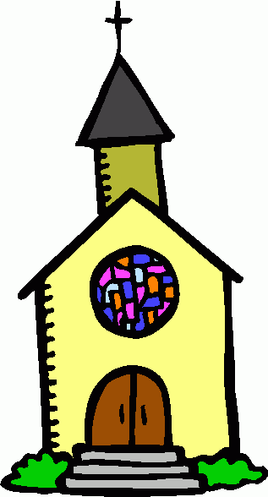
Mequon United Methodist Church Family Registration 2020-2021

Child’s Name ___________________________________ Age ___ Birthday _________T-Shirt Size ______

Grade ___School ____________________ Allergies/Special Needs ____________________________

Child’s Name ___________________________________ Age ___ Birthday _________T-Shirt Size ______

Grade ___School ____________________ Allergies/Special Needs ____________________________

Child’s Name ___________________________________ Age ___ Birthday _________ T-Shirt Size _____

Grade ___School ____________________ Allergies/Special Needs ____________________________

Parent/s Name/s ________________________________________________________________________

Address __________________________________________________________________________

__________________________________________________________________________

e-mail/s __________________________________________________________________________

Phone numbers where you can be reached during MUMC programming:

Home _____________________________ Cell _______________________ Other ___________________

Custody of child/ren: ___Both Parents ___Mom ___Dad ___Other _______________________

Persons authorized to pick up child/ren ___ Mom ___Dad ____Others _________________________

Allergies – We often serve snacks and need to know if your child has allergies!
Special needs – We are honored to serve your child with special needs, but we need details.

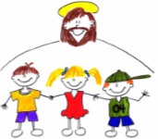
***Please list information about allergies, special needs and additional concerns/things we need to know about your child on the back of this form!
Our program cannot run without volunteers. Can you help…

____ As a Teacher ____ Show Movies ___ Substitute Teach
____ As an Assistant ____ Prepare Crafts ___ Provide Snacks

Signatures Required Below!

In the event of a medical emergency where I cannot be reached, I authorize representatives from Mequon United Methodist Church to consent to treatment for my child/ren at the nearest medical facility. I also authorize transport of my child to this facility.

Parent/Guardian Signature _________________________________________________ Date __________

Children who attend events at Mequon United Methodist Church may be photographed as they participate in activities. These pictures may be published in the newspapers, church publications, and on the church’s website and Facebook page. I authorize the use of my child/ren’s pictures by Mequon United Methodist Church.

Parent/Guardian Signature _________________________________________________ Date __________

